AI-Assisted Farming for Crop Recommendation & Farm Yield Prediction Application

Hack Challenge 2021

CHATFARM

Developers : SURAJ TIWARI & MAULIK MANGUKIYA

Institution : THE ASSAM ROYAL GLOBAL UNIVERSITY &

S. B. P PATEL ENGINEERING COLLEGE

Project ID : SPS_PRO_1992

Mentor : VENKATESH A

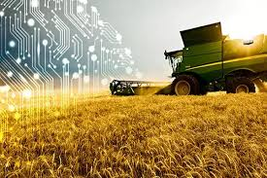

INDEX

1. INTRODUCTION
2. LITERATURE SURVEY
3. THEORITICAL ANALYSIS
4. FLOWCHART
5. RESULT
6. ADVANTAGES & DISADVANTAGES
7. APPLICATIONS
8. CONCLUSION
9. Enhancements that can be made in the future
10. BIBILOGRAPHY
11. Introduction

Overview :-

* Challenges faced in Agriculture with traditional farming techniques.
* How we can overcome challenges in Agriculture with the Application of AI in Agriculture.
* Chat Fram will help to analysis a data with a accurate 60% data.
* Where it was developed under the IBM Cloud using WATSON and NODE RED.

Purpose:-

Digital Farming and Precision Agriculture allow precise utilization of inputs like seed, water, pesticides, and fertilizers at the right time to the crop for maximizing productivity, quality and yields. Most of the farmers practice traditional farming patterns to decide crops to be cultivated in a field. Thus, the solution to this Challenge can be a crop recommendation system that helps farmers to decide the right crop to sow in their field and forecast the yield & revenue.

1. LITERATURE SURVEY

**Existing problem Existing approaches or method to solve this problem.**

Agriculture has evolved with mankind through centuries. Today, agriculture contributes 3.8% to the world’s GDP, although the contribution of individual nations across the spectrum varies widely, between 0%-60%. Over the years, while its share in the world economy has reduced vis-à-vis manufacturing and services, the importance of agriculture hasn’t.

The demand for food is never ending and is projected to increase by 70% by 2050 with limited natural resources at disposal. This situation throws up unique challenges; advanced technologies may be a solution. Here's a look at how IBM (IBM) is applying advanced technologies such as Artificial Intelligence (AI) and cognitive computing in the agricultural sector.

1. THEORITICAL ANALYSIS

**3.1 Block diagram Diagrammatic overview of the project.**

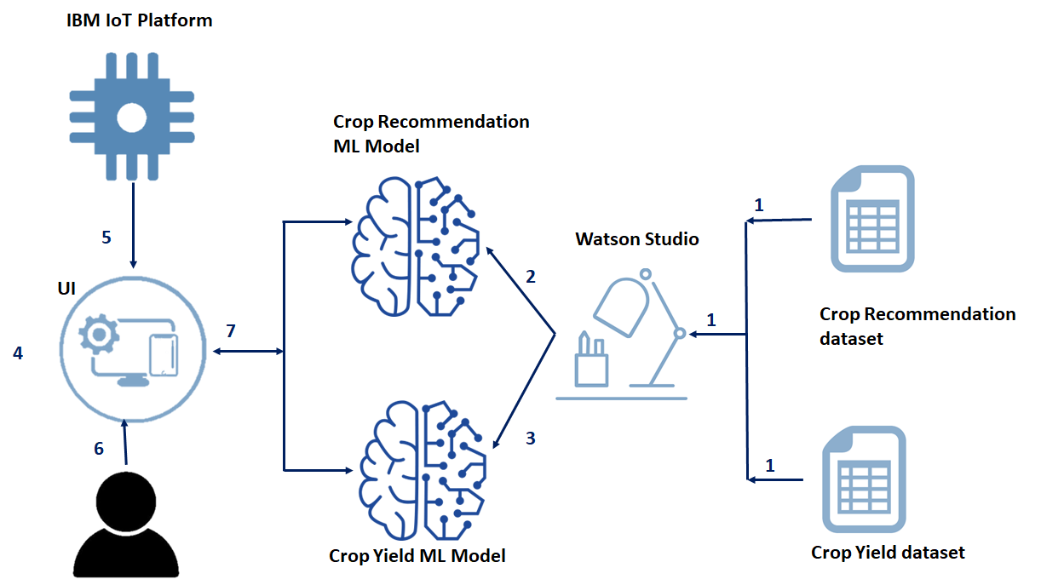

3.2 Hardware / Software designing Hardware and software requirements of the project

**IBM Watson Desktop, IBM Cloud, IBM Auto AI, IBM Watson Studio, Android / any Web frameworks.**

1. FLOWCHART

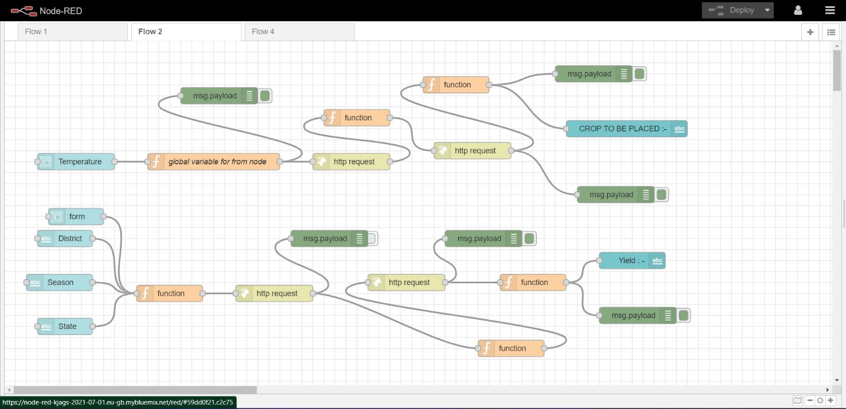

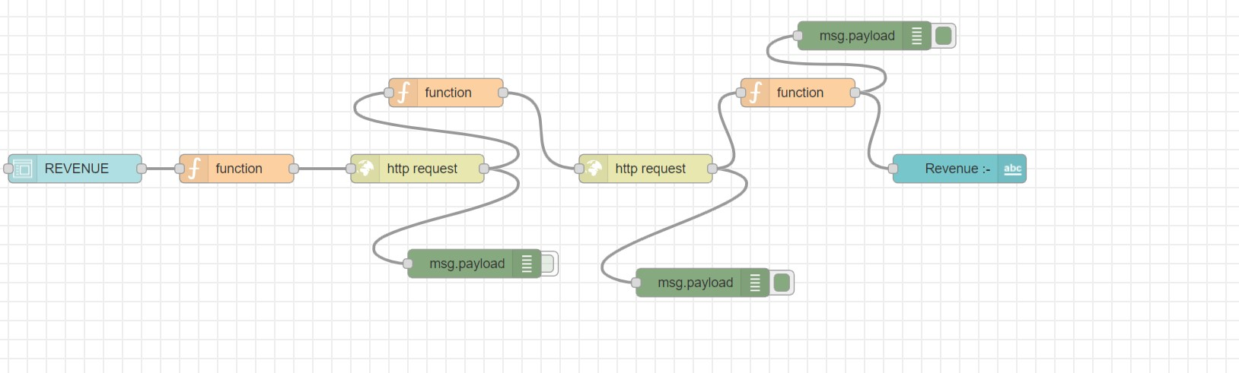

1. RESULT

AI can **provide farmers with real-time insights from their fields**, allowing them to identify areas that need irrigation, fertilization, or pesticide treatment. Also, innovative farming practices like vertical agriculture may help increase food production while minimizing the use of resources. With new technology practice which is very help in the area of AI with the farmer and have a great result which help them to analysis the crop on real time , and help the to predict their losses and have a growth in a proper area with a great technology practice.

1. ADVANTAGES & DISADVANTAGES

Advantages:-

* Analyzing market demand. AI can simplify crop selection and help farmers identify what produce will be most profitable.
* Managing risk.
* Breeding seeds.
* Monitoring soil health.
* Protecting crops.
* Feeding crops.
* Harvesting.

Disadvantage:-

* HIGH COST OF IMPLEMENTATION. Setting up AI-based machines, computers, etc. ...
* CAN'T REPLACE HUMANS. It is beyond any doubt that machines perform much more efficiently as compared to a human being.
* DOESN'T IMPROVE WITH EXPERIENCE.
* LACKS CREATIVITY.
* RISK OF UNEMPLOYMENT.

1. APPLICATIONS

The industry is turning to Artificial Intelligence technologies to help yield healthier crops, control pests, monitor soil, and growing conditions, organize data for farmers, help with the workload, and improve a wide range of agriculture-related tasks in the entire food supply chain.

**Use of weather forecasting:** With the change in climatic condition and increasing pollution it’s difficult for farmers to determine the right time for sowing seed, with help of Artificial Intelligence farmers can analyze weather conditions by using weather forecasting which helps they plan the type of crop can be grown and when should seeds be sown.

**Soil and crop health monitoring system**: The type of soil and nutrition of soil plays an important factor in the type of crop is grown and the quality of the crop. Due to increasing, deforestation soil quality is degrading and it’s hard to determine the quality of the soil.

A German-based tech start-up PEAT has developed an AI-based application called Plantix that can identify the nutrient deficiencies in soil including plant pests and diseases by which farmers can also get an idea to use fertilizer which helps to improve harvest quality. This app uses image recognition-based technology. The farmer can capture images of plants using smartphones. We can also see soil restoration techniques with tips and other solutions through short videos on this application.

Similarly, Trace Genomics is another machine learning-based company that helps farmers to do a soil analysis to farmers. Such type of app helps farmers to monitor soil and crop’s health conditions and produce healthy crops with a higher level of productivity.

**Analyzing crop health by drones:**SkySqurrel Technologies has brought drone-based Ariel imaging solutions for monitoring crop health. In this technique, the drone captures data from fields and then data is transferred via a USB drive from the drone to a computer and analyzed by experts.

This company uses algorithms to analyze the captured images and provide a detailed report containing the current health of the farm. It helps the farmer to identify pests and bacteria helping farmers to timely use of pest control and other methods to take required action

**Precision Farming and Predictive Analytics:**AI applications in agriculture have developed applications and tools which help farmers inaccurate and controlled farming by providing them proper guidance to farmers about water management, crop rotation, timely harvesting, type of crop to be grown, optimum planting, pest attacks, nutrition management.

While using the machine learning algorithms in connection with images captured by satellites and drones, AI-enabled technologies predict weather conditions, analyze crop sustainability and evaluate farms for the presence of diseases or pests and poor plant nutrition on farms with data like temperature, precipitation, wind speed, and solar radiation.

Farmers without connectivity can get AI benefits right now, with tools as simple as an SMS-enabled phone and the Sowing App. Meanwhile, farmers with Wi-Fi access can use AI applications to get a continually AI-customized plan for their lands. With such IoT- and AI-driven solutions, farmers can meet the world’s needs for increased food sustainably growing production and revenues without depleting precious natural resources.

In the future, AI will help farmers evolve into agricultural technologists, using data to optimize yields down to individual rows of plants

**Agricultural Robotics:**AI companies are developing robots that can easily perform multiple tasks in farming fields. This type of robot is trained to control weeds and harvest crops at a faster pace with higher volumes compared to humans.

These types of robots are trained to check the quality of crops and detect weed with picking and packing of crops at the same time. These robots are also capable to fight with challenges faced by agricultural force labor.

**AI-enabled system to detect pests:**Pests are one of the worst enemies of the farmers which damages crops.

AI systems use satellite images and compare them with historical data using AI algorithms and detect that if any insect has landed and which type of insect has landed like the locust, grasshopper, etc. And send alerts to farmers to their smartphones so that farmers can take required precautions and use required pest control thus AI helps farmers to fight against pests.

1. CONCLUSION

Artificial Intelligence in agriculture not only helping farmers to automate their farming but also shifts to precise cultivation for higher crop yield and better quality while using fewer resources.

Companies involved in improving machine learning or Artificial Intelligence-based products or services like training data for agriculture, drone, and automated machine making will get technological advancement in the future will provide more useful applications to this sector helping the world deal with food production issues for the growing population.

1. Enhancements that can be made in the future

In farming climatic factors such as rainfall, temperature and humidity play an important role in the agriculture lifecycle. Increasing deforestation and pollution result in climatic changes, so it’s difficult for farmers to take decisions to prepare the soil, sow seeds, and harvest.

 Every crop requires specific nutrition in the soil. There are 3 main nutrients nitrogen(N), phosphorous(P) and potassium(K) required in soil. The deficiency of nutrients can lead to poor quality of crops.

 As we can see from the agriculture lifecycle that weed protection plays an important role. If not controlled it can lead to an increase in production cost and also it absorbs nutrients from the soil which can cause nutrition deficiency in the soil.

1. BIBILOGRAPHY

* <https://nodered.org>
* [CHATFARM (mybluemix.net)](https://node-red-kjags-2021-07-01.eu-gb.mybluemix.net/ui/#!/0?socketid=KuW1uIka5CERB96FAAAA)
* [IBM Watson | IBM](https://www.ibm.com/watson)